Laser Castle
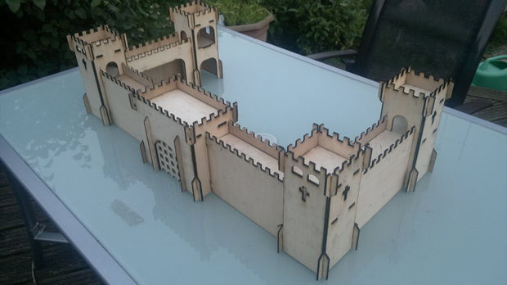
Using a desktop laser cutting machine, I made this wooden castle from 3mm plywood.
The machines used for this was a LS3020 Desktop Laser Engraver. The shapes and designs were created using Autocad (and exported as DXF files for importing into the laser software). The material was standard 3mm plywood, bought in a 8x4 sheet from B&Q for about £15

Step 1: Design & Building

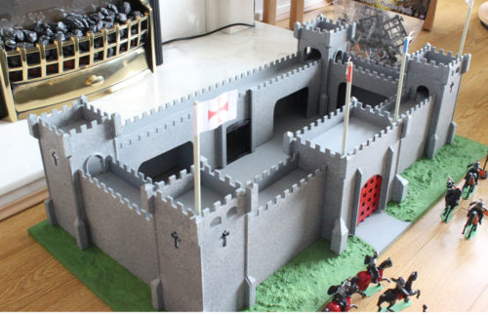
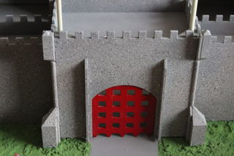
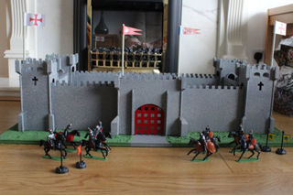
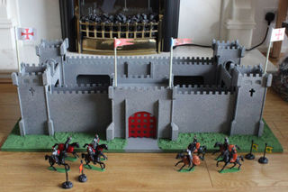
I started out with a simple proof of concept, cut from cardboard, making pieces which slot together and make a simple cube shape. This was extended to make a slightly more complex structure until I was sure that it would be possible to make a full castle.
I made a number of small pieces to check and measure that the pieces of plywood would slot together in such a fashion to minimize the need for any glue.
When I was happy that I had these measurements and that I had the correct settings for the laser cutter, I then proceeded to cut the more complex shapes and start building. The build started with the portcullis section with some pieces being cut a second time, with additional slots added for the connecting walls ... the same was then done for the corner turrets until a complete castle was built.
With the castle in competed form, adding the decorative elements produced a finished and very pleasing looking castle.
By using the technique of 'slotting' parts together proved advantageous, as these could easily be swapped out and improvements made to the overall design with relative ease.
The 3mm sheets of plywood being inexpensive, was a great material choice and certainly forms the basis on which future and more complicated projects will be made.

Step 2: Design & Files

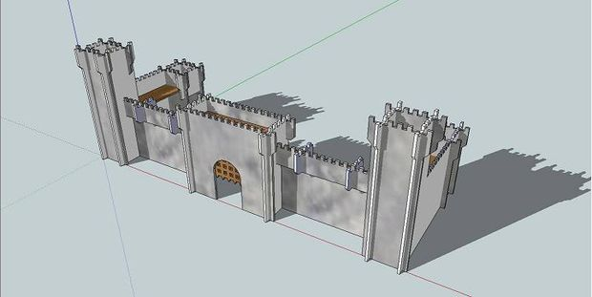
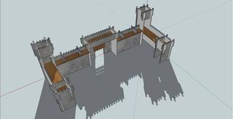
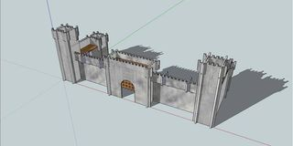
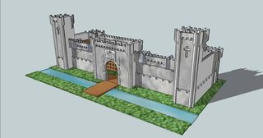
Have attached some of the images which I produced with Google SketchUp and the main DXF file which I used for cutting ~ due to the size of my laser cutter, these were cut in parts, on panels of the plywood, which I had sized down to approximately 30cm x 30cm

